AWS Cloud Discovery Configuration
Step1 : Configure Cloud Discovery Workspace related to API's
Setp2 : Create IAM user in AWS console and Access key 1
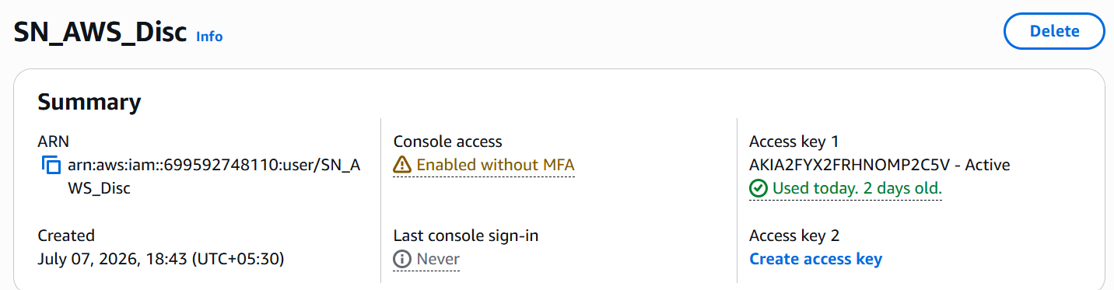
Method 1: Attach Permissions to an IAM User
- Sign in to the AWS Management Console.
- Open IAM → Users.
- Select the IAM user.
- Go to the Permissions tab.
- Click Add permissions.
- Choose:
  - Attach policies directly (recommended for quick assignment), or
  - Add user to group (best practice for multiple users).
- Select the required policy (for example, AmazonS3ReadOnlyAccess, AdministratorAccess, etc.).
- Click Next → Add permissions.
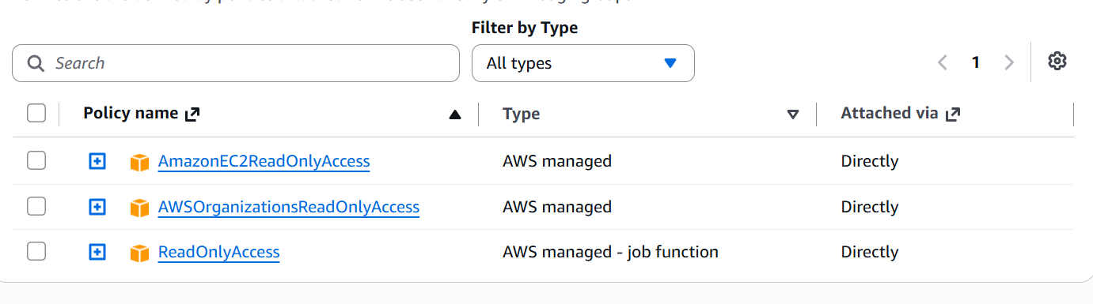
Step 3 : Create IAM roles with policies.
Method 2: Allow an IAM User to Assume a Role
If you want a user to use a role:
- Create or select the IAM Role.
- Edit the Role's Trust Relationship to allow the IAM user to assume it.
- Attach a policy to the IAM user that allows sts:AssumeRole.
- The user can then switch to that role from the AWS Console or use AWS CLI assume-role.
{
"Version": "2012-10-17",
"Statement": [
{
"Effect": "Allow",
"Principal": {
"AWS": "arn:aws:iam::ACCOUNT_ID:user/USERNAME"
},
"Action": "sts:AssumeRole"
}
]
}
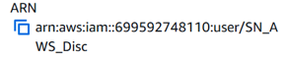
Step 4 : Create EC2 instance along with Elastic IP in AWS console
Step 5 : Install MID server in EC2 instance.
Step 6 : Create credentials in ServcieNow instance
All Discovery Credentials New AWS Credentials
Access Key and Secret Access key for Step2
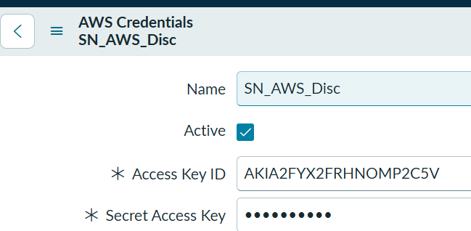
Step 7 : Configure the MID Server for AWS IAM roles
Procedure
- Navigate to All > Discovery > MID Servers.
- Select a MID Server installed on an Amazon EC2 instance within the relevant AWS service account.
- Open the Configuration Parameters related list.
- Click New.
- In the configuration parameter form, select mid.aws.instance_profile_name in the Parameter name field.
- Enter the name of the IAM role attached to the EC2 Instance in the Value field.
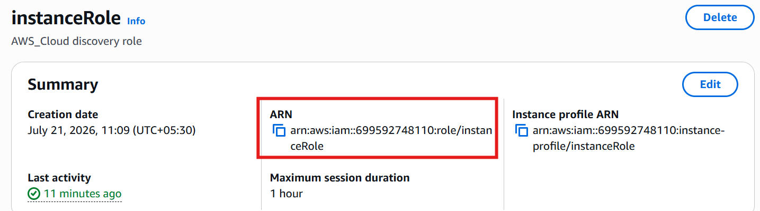
- Click Submit.
The new parameter is listed in the MID Server record.
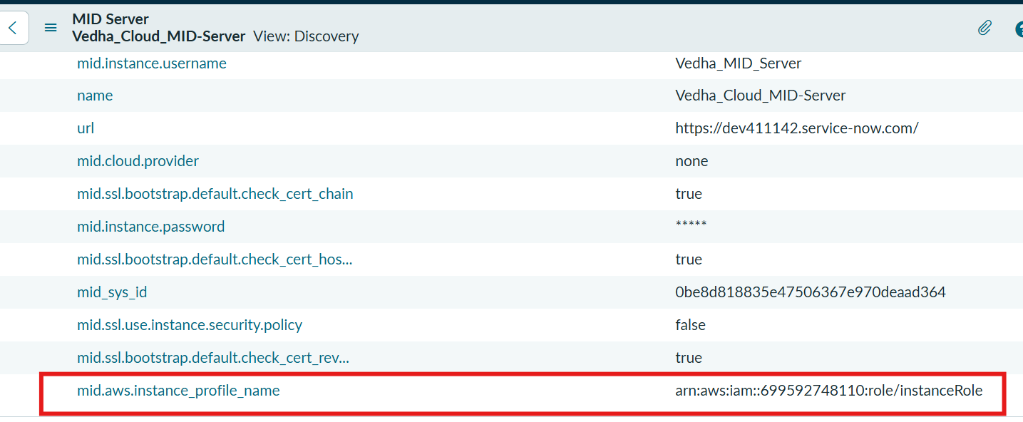
Step 8 : New Schedule for Cloud Discovery
Cloud discovery workspace Cloud discovery New discovery schedule
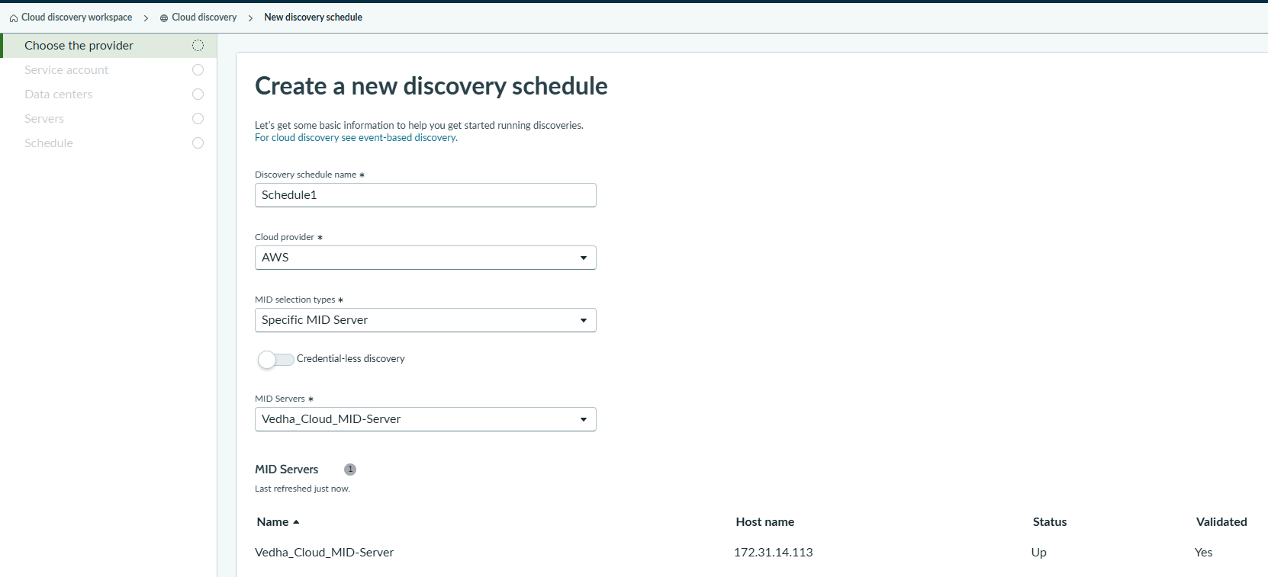
Account ID is AWS console account ID
cmdb_ci_cloud_service_account.list (Cloud discovery service account list)
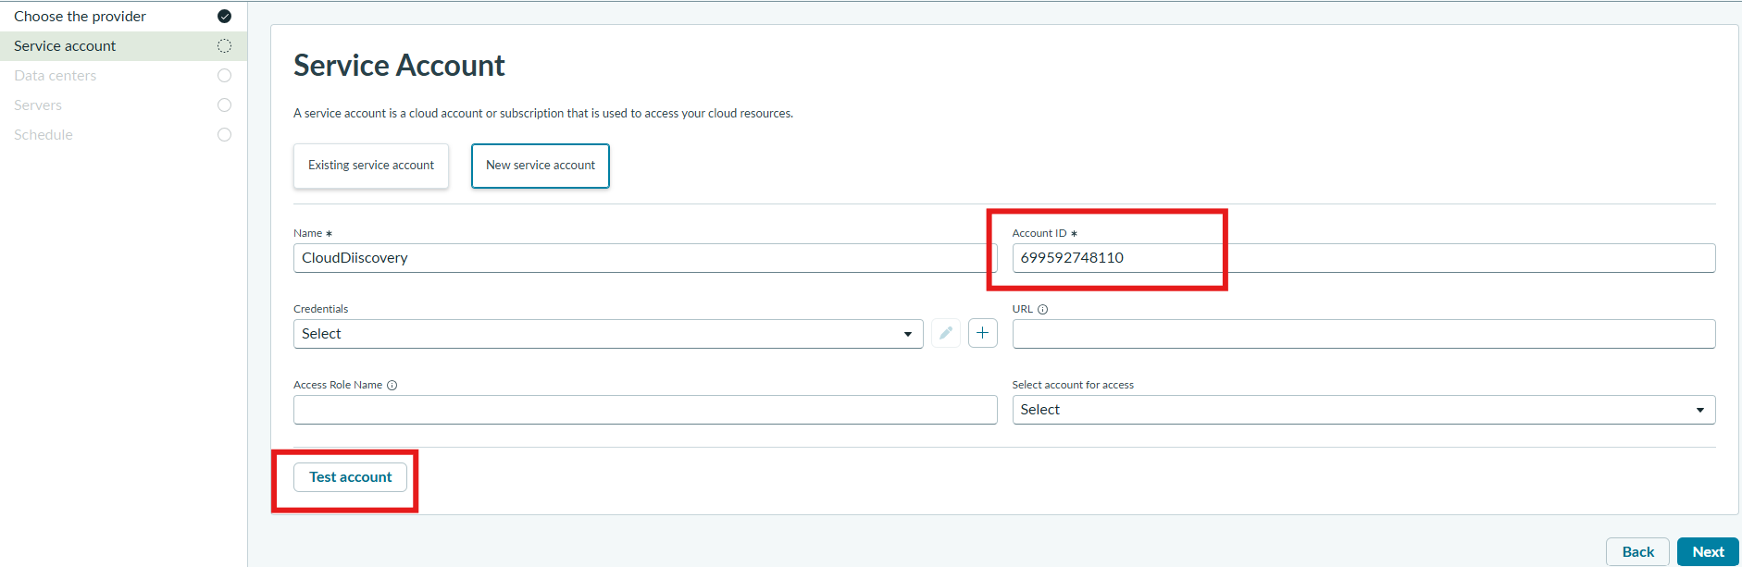
Select All data centers or Specific Data Centers
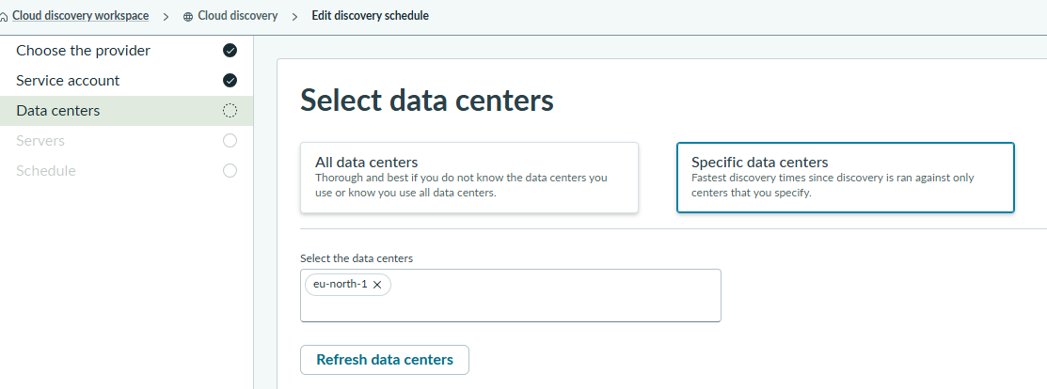
Select MID server name
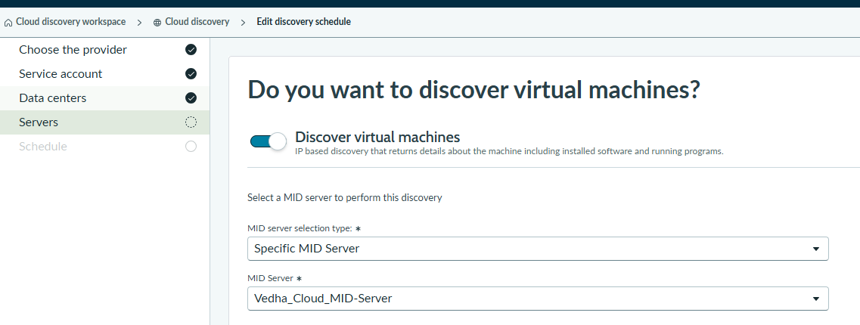
Schedule when this discovery runs
